✅ Lab 4 — One-Dimensional & Two-Dimensional Arrays
(Formatted exactly like Lab 2 & 3)

Objectives
By the end of this lab, you will be able to:
- Declare and initialize one-dimensional arrays
- Access and update array elements
- Process arrays using loops
- Find min, max, and average values
- Declare and process two-dimensional arrays
- Use nested loops with arrays

Part 1 — One-Dimensional Arrays (1D)
Question 1 — Array Initialization
Declare an array of size 5 and store the numbers:
10, 20, 30, 40, 50
Then print all elements.
Answer:
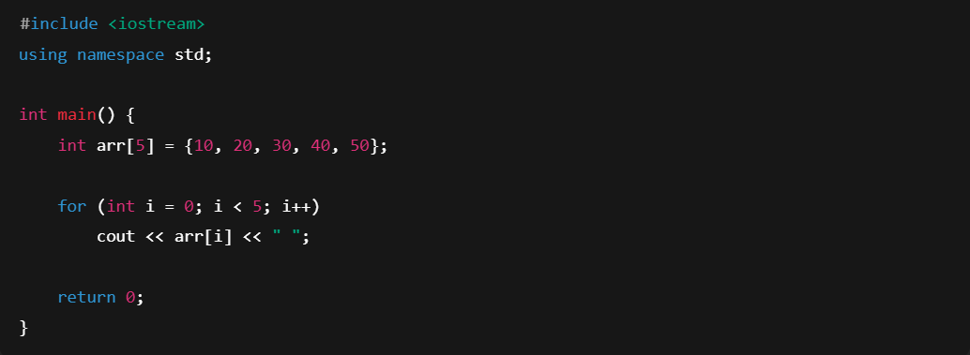

Question 2 — Input + Sum of Array
Ask the user to enter 5 integers, store them in an array, then print the sum.
Answer:
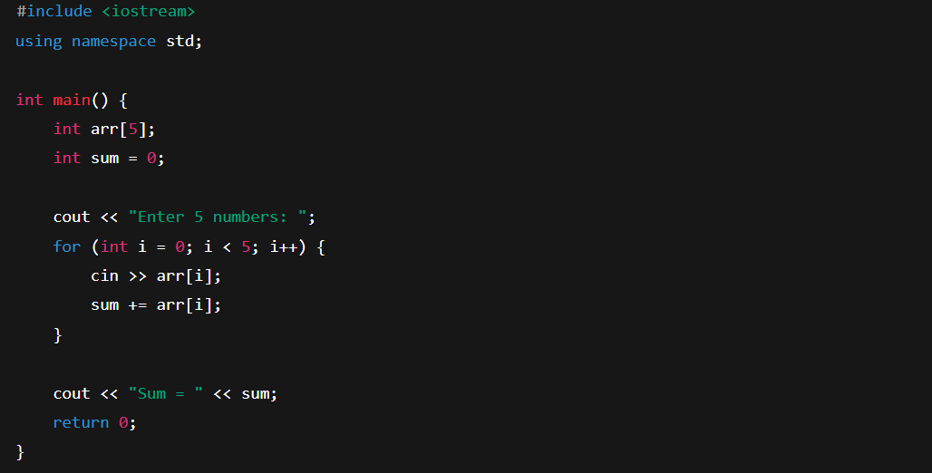

Question 3 — Finding the Largest Element
Write a program that reads 6 integers into an array and prints the largest value.
Answer:
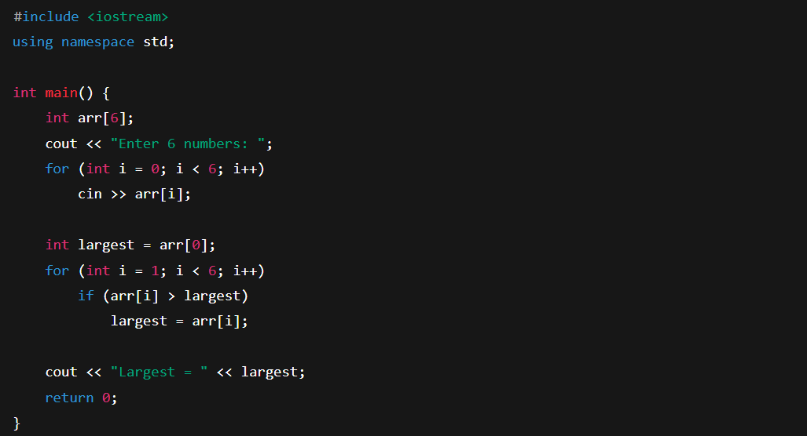

Part 2 — Array Processing Algorithms
Question 4 — Count Positive Numbers
Ask the user for 8 integers and count how many are positive.
Answer:
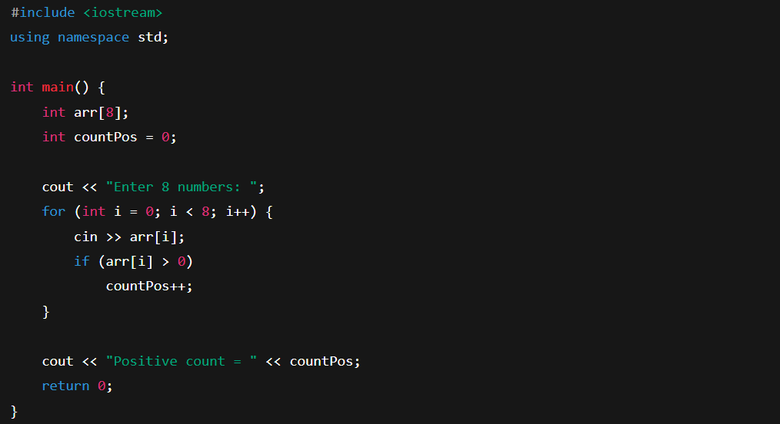

Question 5 — Average of Array Elements
Input 10 numbers, find the average, and print it.
Answer:
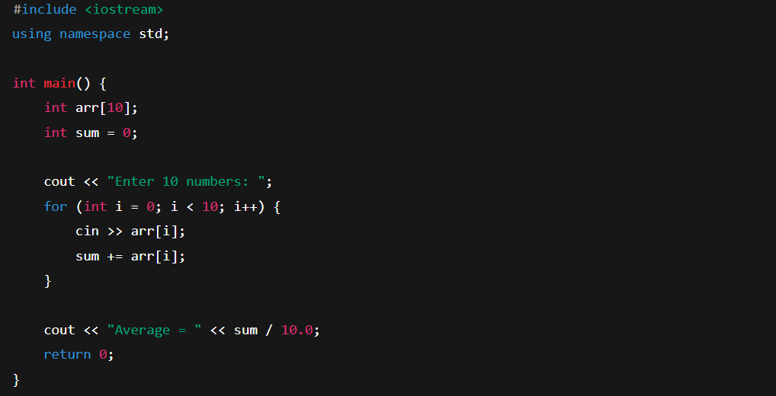

Part 3 — Two-Dimensional Arrays (2D)
Question 6 — Input and Display a 2×3 Matrix
Ask the user to enter values for a 2-row, 3-column matrix, then print the matrix.
Answer:
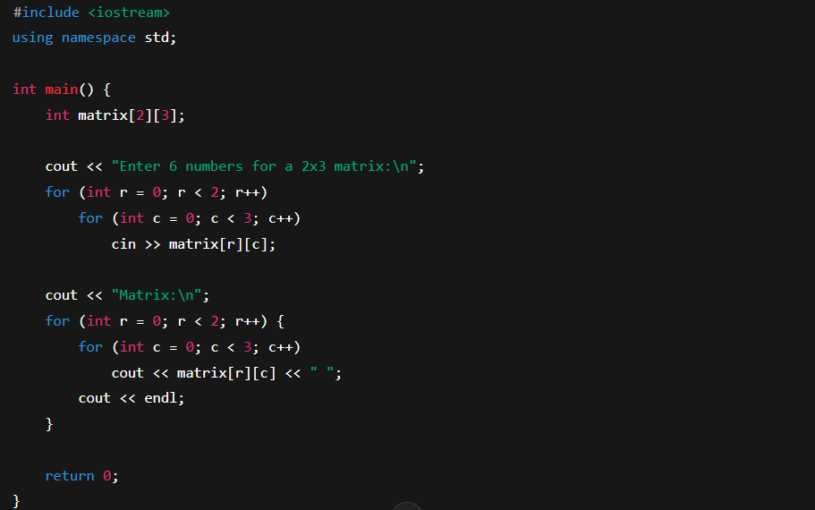

Question 7 — Sum of Each Row
Given a 3×3 matrix, compute and print the sum of each row.
Answer:
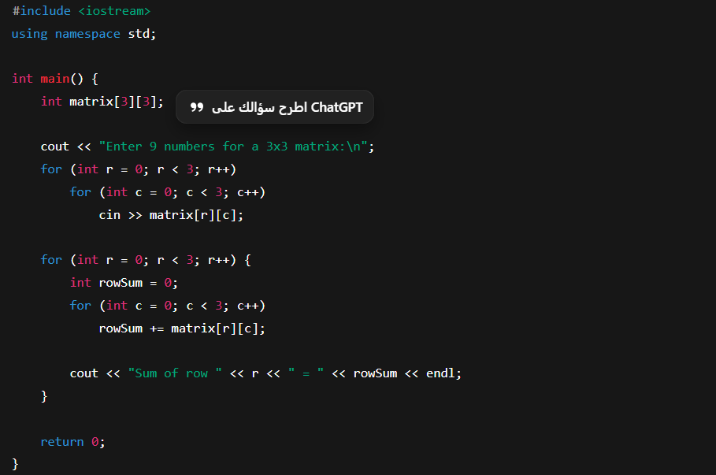

Part 4 — Searching Arrays
Question 8 — Search for a Value
Ask the user for 10 numbers, then ask for a value x and check if x exists in the array.
Answer:
